# JIRA Manager Report

The [JIRA Manager Report](https://app.powerbi.com/groups/me/reports/94c77a69-8c60-45e8-8116-3c70a23b65f7?ctid=be0f980b-dd99-4b19-bd7b-bc71a09b026c) provides a look into the current sprint and some historical data relating to the sprint items.

## Sprint Dashboard

This dashboard has two different views, the first being the Story Point view and the other relating to issue counts. Each page is limited to the specific projects using that methodology. The issue page is identical except for the measurement method.

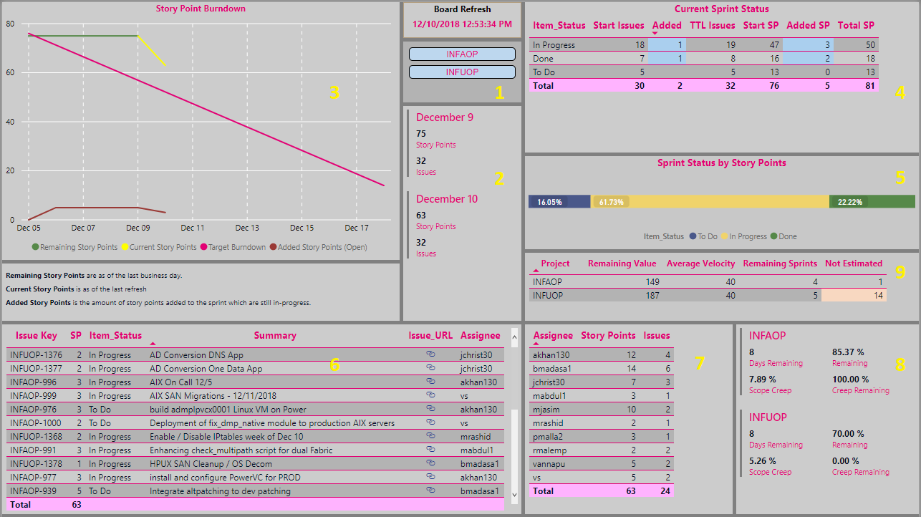

|  |  |
| --- | --- |
| 1 | You filter the report data based upon the selected projects. When selected, the project ID is blue. |
| 2 | Based upon the project, this is the information for the current and prior day |
| 3 | The goal of the burndown report is to show how we are progressing towards the end of sprint completion.   * Remaining Story Points [Green] – story points as of the end of the prior business day * Current Story Points [Yellow] – the story points as of the time of the last refresh * Added Story Points [Brown] - shows the number of story points for opened issues which are still pending. The object is to highlight those items which are a ‘must finish’ by the end of the sprint. |
| 4 | This tabular representation visualizes the current item status. The added columns populate when users add new issues mid-sprint. The table shows both the number of issues (first added column) and story points (second) |
| 5 | The graphical representation of the current item status table – less the added items. |
| 6 | This tabular representation visualizes the still open stories.  If you click a status in #4 or #5 **or** an assignee in #7, it causes this view to be limited. |
| 7 | This tabular representation visualizes the number of story points and issues open to specific people. |
| 8 | For the highlighted projects, the shows:   * How many *calendar* days left in the sprint * How much work remains * The percentage of scope creep – measured by added story points divided by the starting SP * How much of the ‘creep work’ remains |
| 9 | Based upon the average velocity over the past six sprints for each project and the amount of work remaining in the backlog, it calculates the number of sprints remaining. Additionally, it shows the number of work items without estimates. |

## Initiative View

The goal of this page is to show the planned initiatives as well as the stories included in each, totaled by story point. These values don’t reflect the actual number of issues in the initiative. However, when you click on a specific initiative, all of the stories appear even if there aren’t story points in the story.

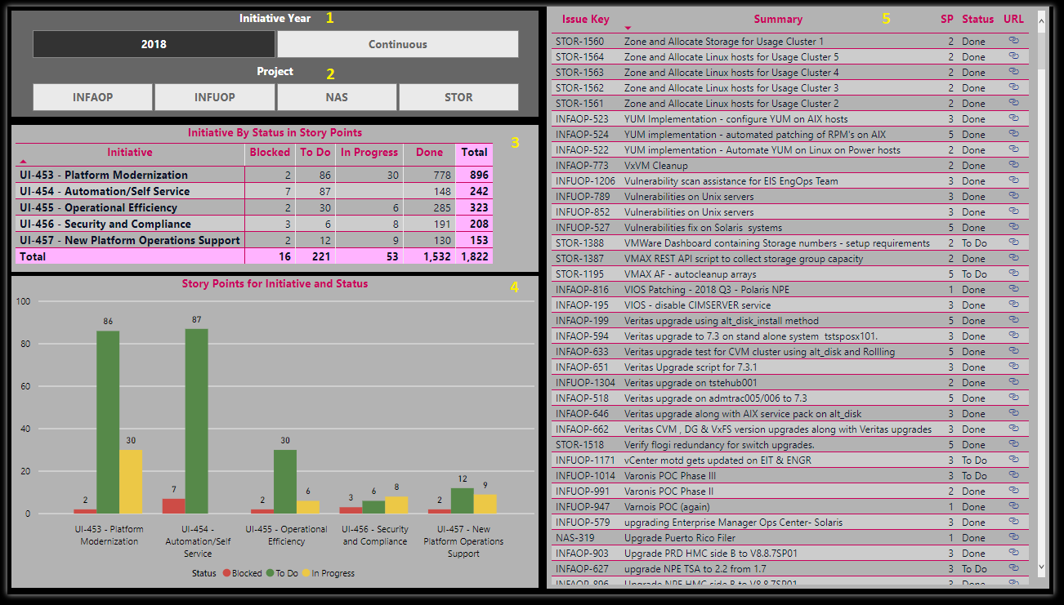

|  |  |
| --- | --- |
| 1 | Select the Initiative Year. Continuous refers to the “keep the lights on” work |
| 2 | Select the Project. If none are selected, then all projects are shown |
| 3 | This table shows the number of story points associated with each initiative |
| 4 | The graphical representation of the Initiative By Status table. |
| 5 | These are the stories associated with the initiative year as well as a link to JIRA.  If you select a specific initiative, status, or both, you filter this list. |

## Epic/Story

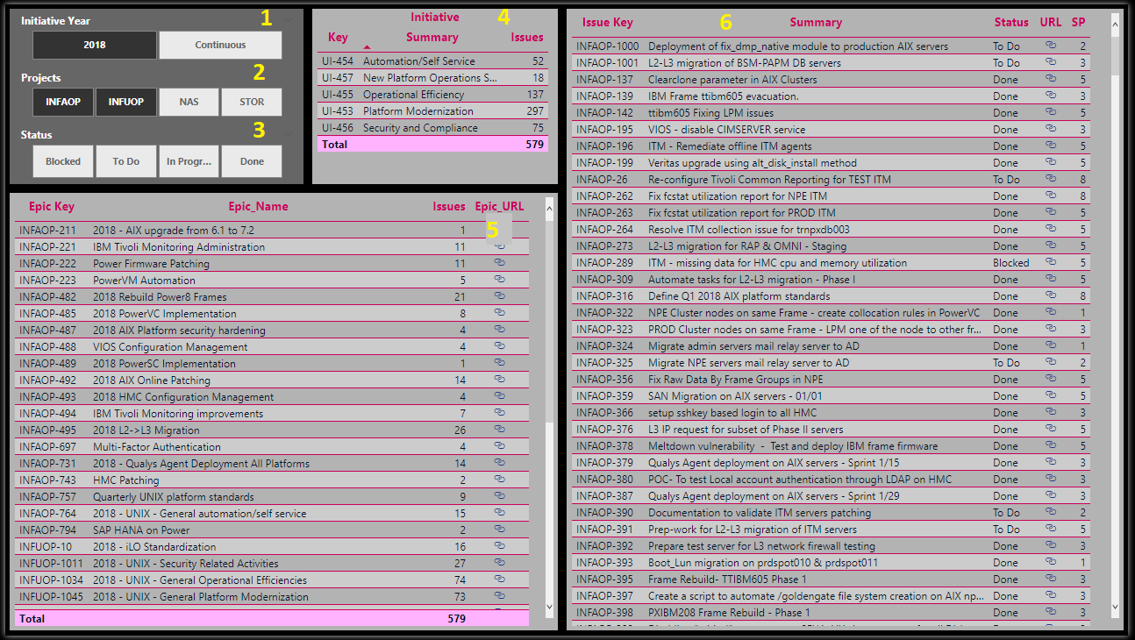

|  |  |
| --- | --- |
| 1 | Select the Initiative Year. Continuous refers to the “keep the lights on” work |
| 2 | Select the Project. If none are selected, then all projects are shown |
| 3 | Select the Status for the combination. If none are selected, then all statuses are shown |
| 4 | This table is a list of initiatives as well as the number of issues in the initiative. You can click on a specific initiative to filter the epics and issues |
| 5 | This table shows the epics based on the filters above. It also shows the number of issues as well as the link to the epic. |
| 6 | These are the stories associated with the initiative year as well as a link to JIRA.  If you select a specific initiative, status, or both, you filter this list. |

## Number of Sprints for Story

This dashboard has two different views, the first being the Story Point view and the other relating to issue counts. The projects shown in #1 are limited based upon the primary method used by the projects.

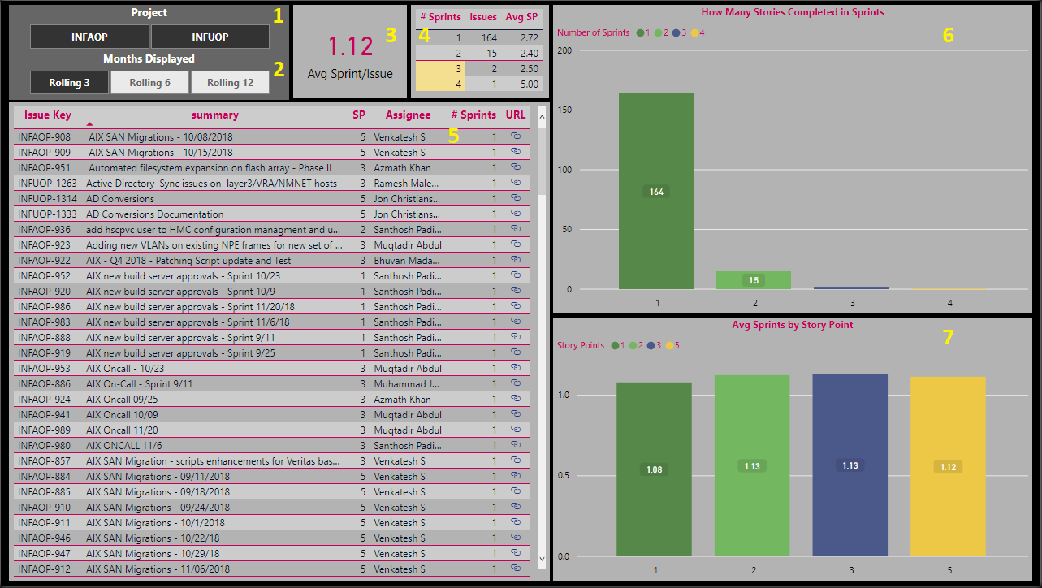

|  |  |
| --- | --- |
| 1 | Select the Project. If none are selected, then all projects are shown |
| 2 | Select the range for the data. If none is selected, then it limits to the current year. Otherwise, it limits to the last 3 months, last 6 months and **over** 6 months.  Use the 3-month view to see how the team has done recently.  They may have made incremental improvements (see any retrospective notes), and this would be a view into it.  Using the 6-month view is relevant to the team’s most recent progress. Anything longer than 6 months is more historical than reflecting the team's current makeup or progression.  **Note:** If nothing is selected it is *not* a rolling 12-month view. |
| 3 | Based upon the filters, this is the average number of sprints that an issue takes to complete |
| 4 | This table represents the number of sprints that stories took, as well as the number of issues and their average story points. |
| 5 | These are the stories associated with the selected filters as well as a link to JIRA. |
| 6 | A graphical representation showing the number of issues broken down by the number of sprints. |
| 7 | A graphical representation showing the average number of sprints broken down by the number of story points.  **Note:** This does not exist on the **Number of Sprints for Story (Issue)** tab. |

## Graphical Notes

### Sprint Review Pages

|  |  |  |
| --- | --- | --- |
| Area | HTML Color | Theme Color |
| Wallpaper | 808080 | White, 50% darker |
| Page Background | 808080 | White, 50% darker |
| Panel Background | CCCCCC | White, 20% lighter |
| Titles and Line Colors | E20074 | None |
| Selector Box (Project) | B3B3B3 | White, 30% darker |
| Highlighting for Projects in Selector Box | AACFEE | Theme Color 6, 40% lighter |
| Total Background Color | FFB3FF | None |
| Grid Header Background Color | Transparent |  |
| Grid Background Color | B3B3B3 | White, 30% darker |
| Grid Alternate Background Color | CCCCCC | White, 20% lighter |
| *Current Sprint Status and Open Issues Tables* | | |
| Background – Conditional Formatting for Added SP and Items Note: Added background has precedence over the blocked | AACFEE | Theme Color 6, 40% lighter |
| Foreground – Conditional Formatting for Blocked Items | FFB3FF | Theme Color 5 |
| Background – Conditional Formatting for Blocked Items | F7E9B5 | Theme Color 4, 60% lighter |
| *Burndown Chart* | | |
| Target Burndown | E20074 | None |
| Remaining Issues | 3A5C31 | Theme Color 2, 50% darker |
| Current Issues The theme colors did not include a bright enough yellow | FFFF00 | None |
| Added Issues (open) | 9A3935 | Theme Color 5, 25% darker |
| Grid | FFFFFF | White |
| *Sprint Status by Story Points (Issues)* | | |
| Blocked | CD4C46 | Theme Color 5 |
| To Do | 4A588A | Theme Color 3 |
| In Progress | F0D36B | Theme Color 4, 20% lighter |
| Done | 568949 | Theme Color 2, 25% darker |
| *Forecasting Block – Not Estimated* | | |
| Background – More than or equal to 10% but less than 30% | F7E9B5 | Theme Color 4, 60% lighter |
| Background – More than or equal to 30% but less than 40% | F8D8C1 | Theme Color 8, 60% lighter |
| Foreground – More than or equal to 40% | FFFFFF | White |
| Background – More than or equal to 40% but less than 90% | D7706B | Theme Color 5, 20% lighter |
| Background – More than or equal to 90% | 000000 | Black |

### Overview Pages

|  |  |  |
| --- | --- | --- |
| Area | HTML Color | Theme Color |
| Wallpaper | **000000** | Black |
| Page Background | **000000** | Black |
| Panel Background | **B3B3B3** | White, 30% darker |
| Titles and Line Colors | **C9005B** | None |
| Selector Box (Project) | **666666** | White, 60% darker |
| Total Background | FFB3FF | None |
| Grid Header Background Color | **CCCCCC** | White, 20% lighter |
| Grid Background Color | B3B3B3 | White, 30% darker |
| Grid Alternate Background Color | CCCCCC | White, 20% lighter |
| *Initiative and Status Bar Graph* | | |
| Grid | FFFFFF | White |
| Blocked | CD4CD6 | Theme Color 5 |
| To Do | 4A588A | Theme Color 3 |
| In Progress | F0D36B | Theme Color 4, 20% lighter |
| Data Labels | FFFFFF | White |
| *Number of Sprints* | | |
| Background – 3 or 4 Sprints | F4DE90 | Theme Color 4, 40% lighter |
| Foreground – 5, 6, or 7 sprints | FFFFFF | White |
| Background – 5, 6, or 7 Sprints | CD4C46 | Theme Color 5 |
| Foreground – 8 or More Sprints | F4DE90 | Theme Color 4, 40% lighter |
| Background – 8 or More sprints | 000000 | Black |